Main Page

Header

* navigation bar - Hour & location, Menu, Meet the team, Our story, reviews
* Restaurant logo(logo-bedi.jpg)
* use img4.jpg as transparent background

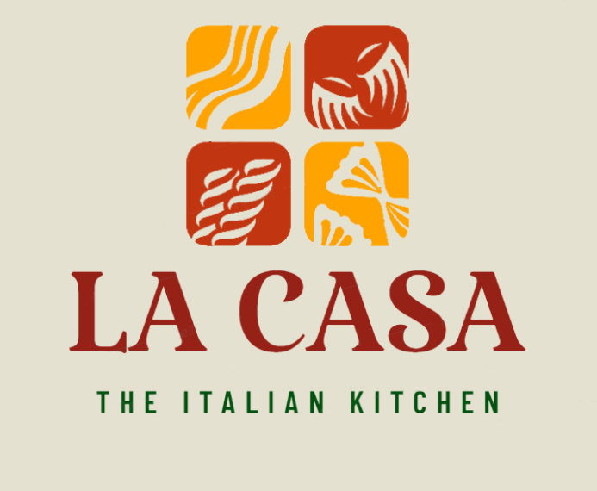

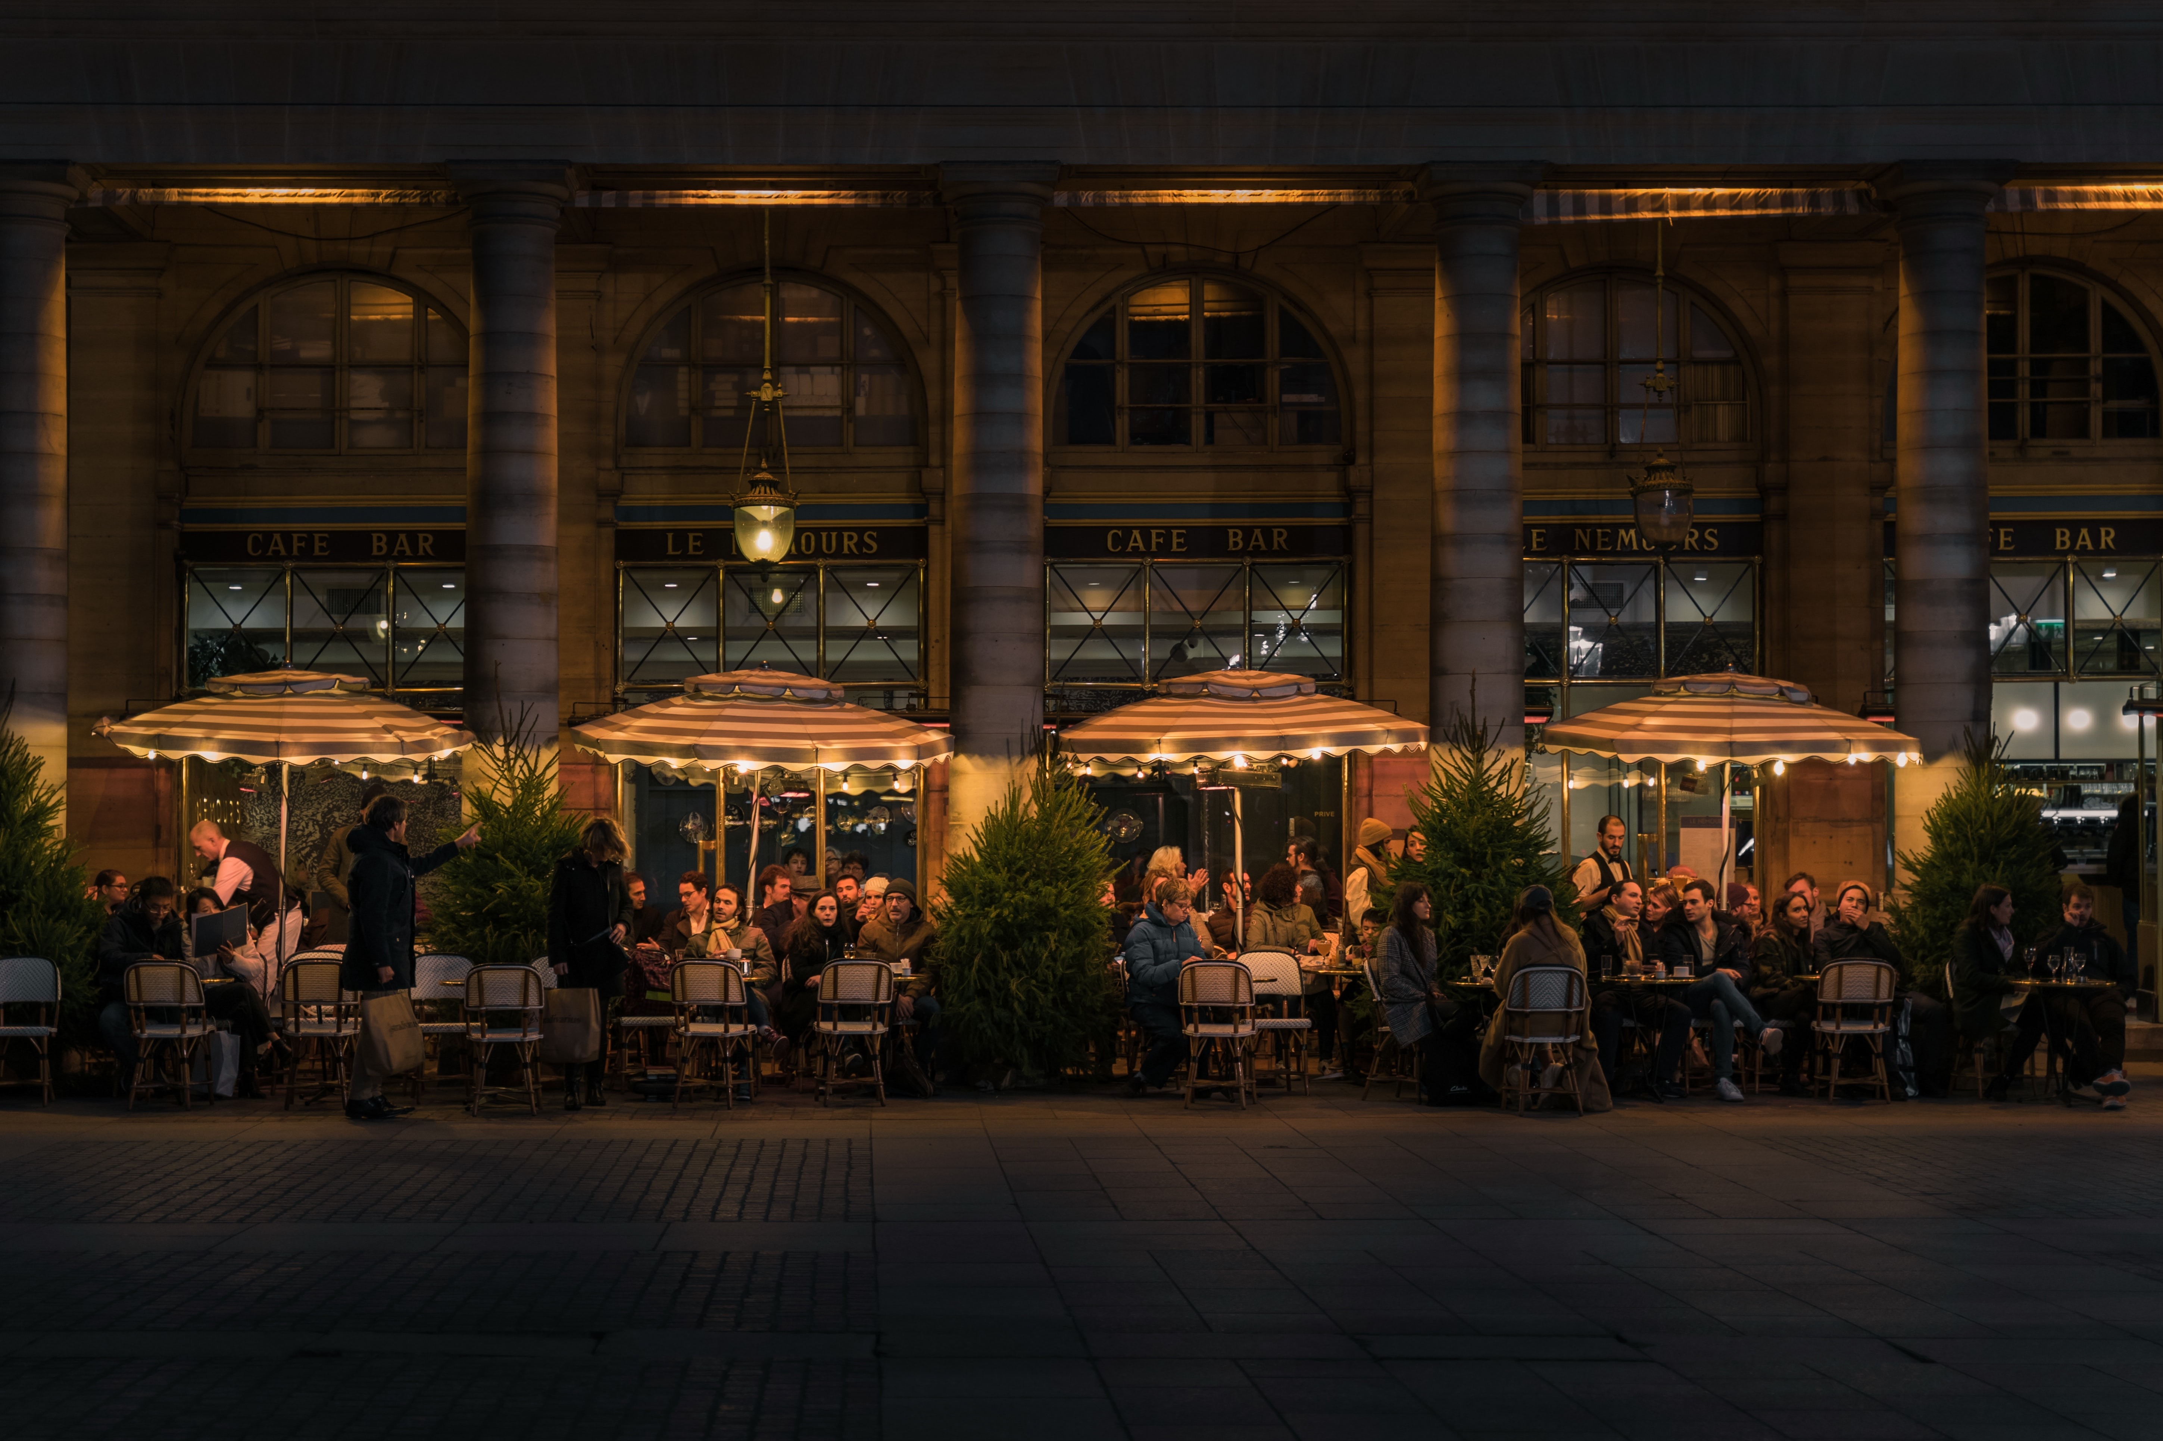

<!-- Citation for external content(img4):

Author: Photo by [Siyuan](https://unsplash.com/@jsycra?utm_source=unsplash&utm_medium=referral&utm_content=creditCopyText) on [Unsplash](https://unsplash.com/s/photos/italian-restaurant?utm_source=unsplash&utm_medium=referral&utm_content=creditCopyText)

URL: <https://unsplash.com/photos/g_V2rt6iG7A>

Date accessed: 11 - Oct - 2021

-->

Main

* Short introduction-Home to authentic homemade Italian food. La Casa has been serving exquisite Italian cuisine since 2001. Using recipes passed down through the generations. Uses locally source fresh ingredients. Each and every dish served in La Casa are prepaid and cook with love.
* Links to menu and our story
* Menu- Discover the authentic Italian cuisine we have to offer(img1.jpg), button-view menu
* Our story- Learn more about la casa(vid), button-Learn more
* Insert img2.jpg, img3.jpg

Footer-contact us(link), address- 6385 South St, Halifax, NS B3H 4J4

<!-- Citation for external content(img1):

Author: Photo by [Bruna Branco](https://unsplash.com/@brunabranco?utm_source=unsplash&utm_medium=referral&utm_content=creditCopyText) on [Unsplash](https://unsplash.com/s/photos/italian-food?utm_source=unsplash&utm_medium=referral&utm_content=creditCopyText)

URL: <https://unsplash.com/photos/t8hTmte4O_g>

Date accessed: 11 - Oct - 2021

-->

<!-- Citation for external content(img2):

Author: Photo by [Luisa Brimble](https://unsplash.com/@luisabrimble?utm_source=unsplash&utm_medium=referral&utm_content=creditCopyText) on [Unsplash](https://unsplash.com/s/photos/italian-food?utm_source=unsplash&utm_medium=referral&utm_content=creditCopyText)

URL: <https://unsplash.com/photos/vIm26fn_QKg>

Date accessed: 11 - Oct - 2021

-->

<!-- Citation for external content(img3):

Author: Photo by [Foad Roshan](https://unsplash.com/@rfrsrh?utm_source=unsplash&utm_medium=referral&utm_content=creditCopyText) on [Unsplash](https://unsplash.com/s/photos/pizza?utm_source=unsplash&utm_medium=referral&utm_content=creditCopyText)

URL: <https://unsplash.com/photos/Y6OgisiGBjM>

Date accessed: 11 - Oct - 2021

-->

<!-- Citation for external content(vid):

Author: Video by Pavel Danilyuk from Pexels

URL: <https://www.pexels.com/video/person-pouring-wine-in-a-wine-glass-8764784/>

Date accessed: 13 - Oct - 2021

-->

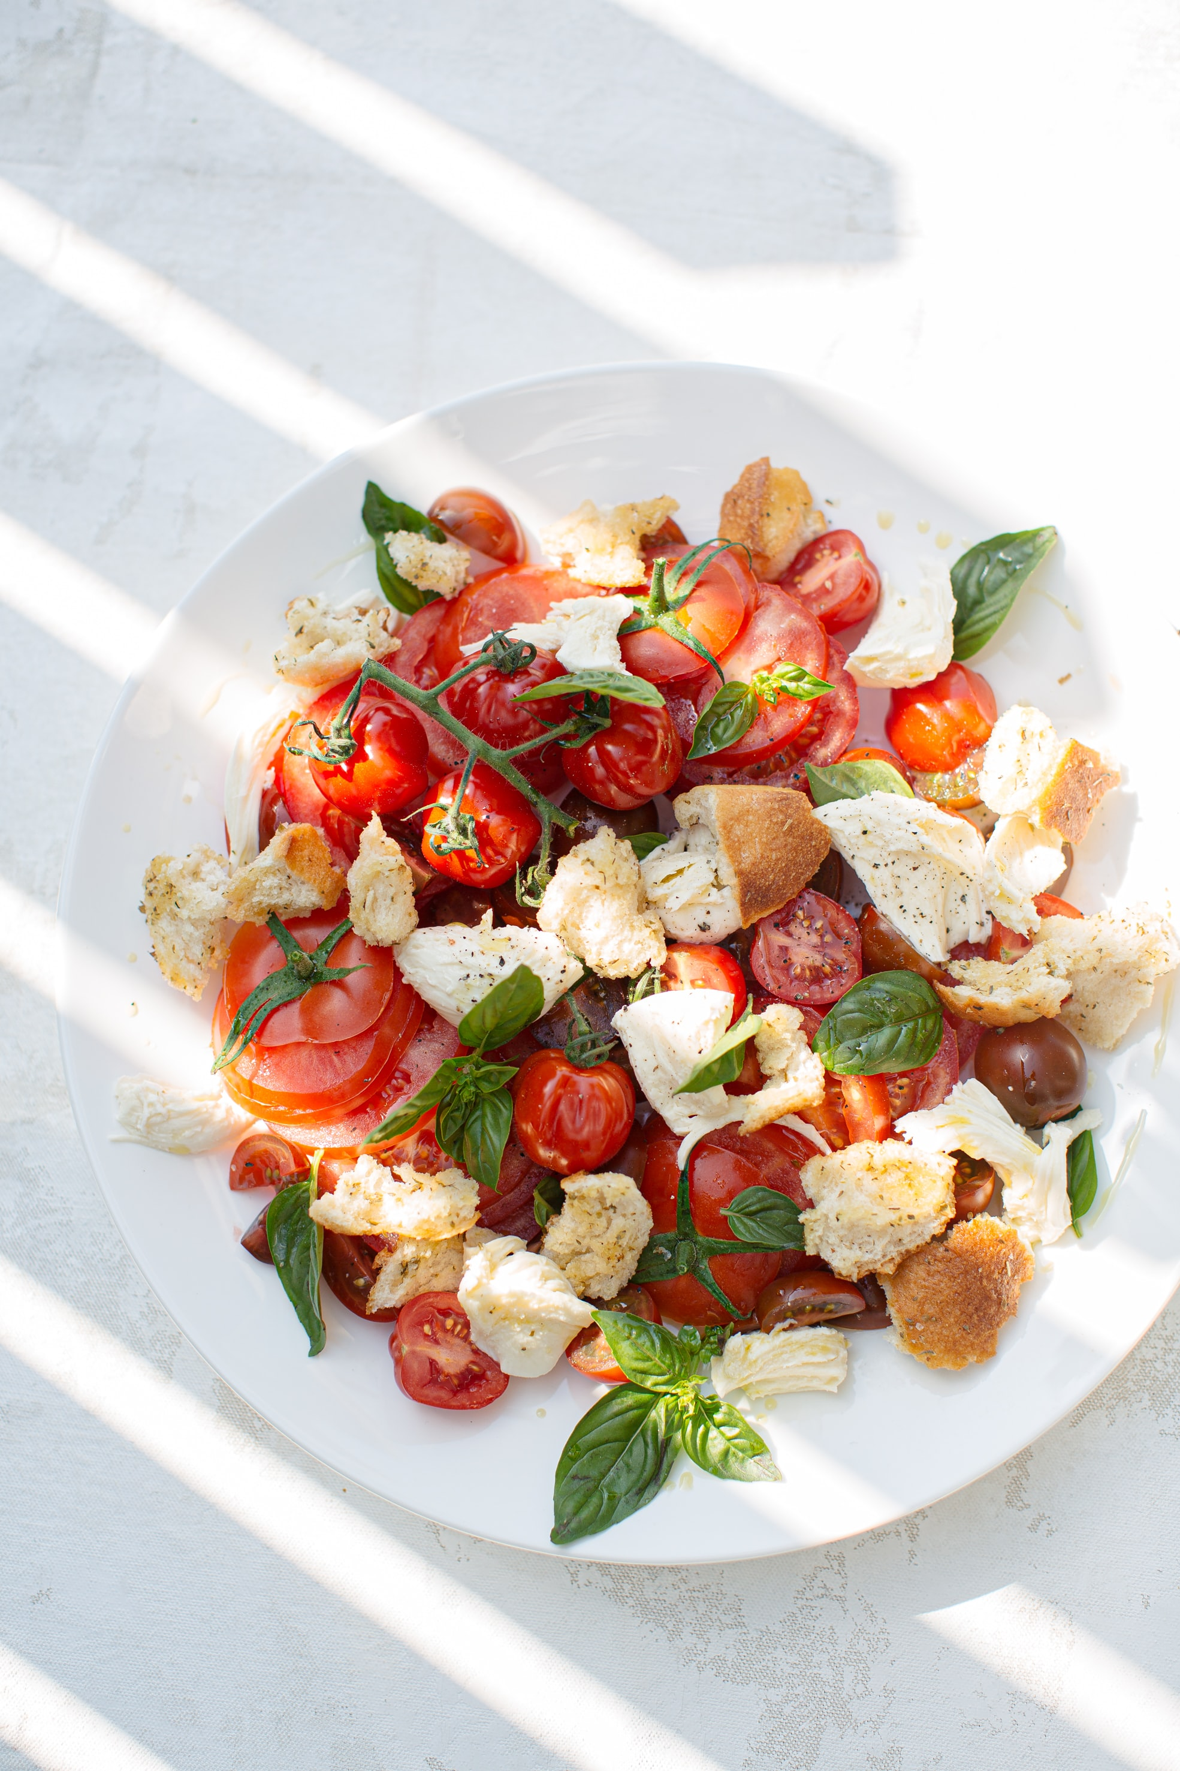

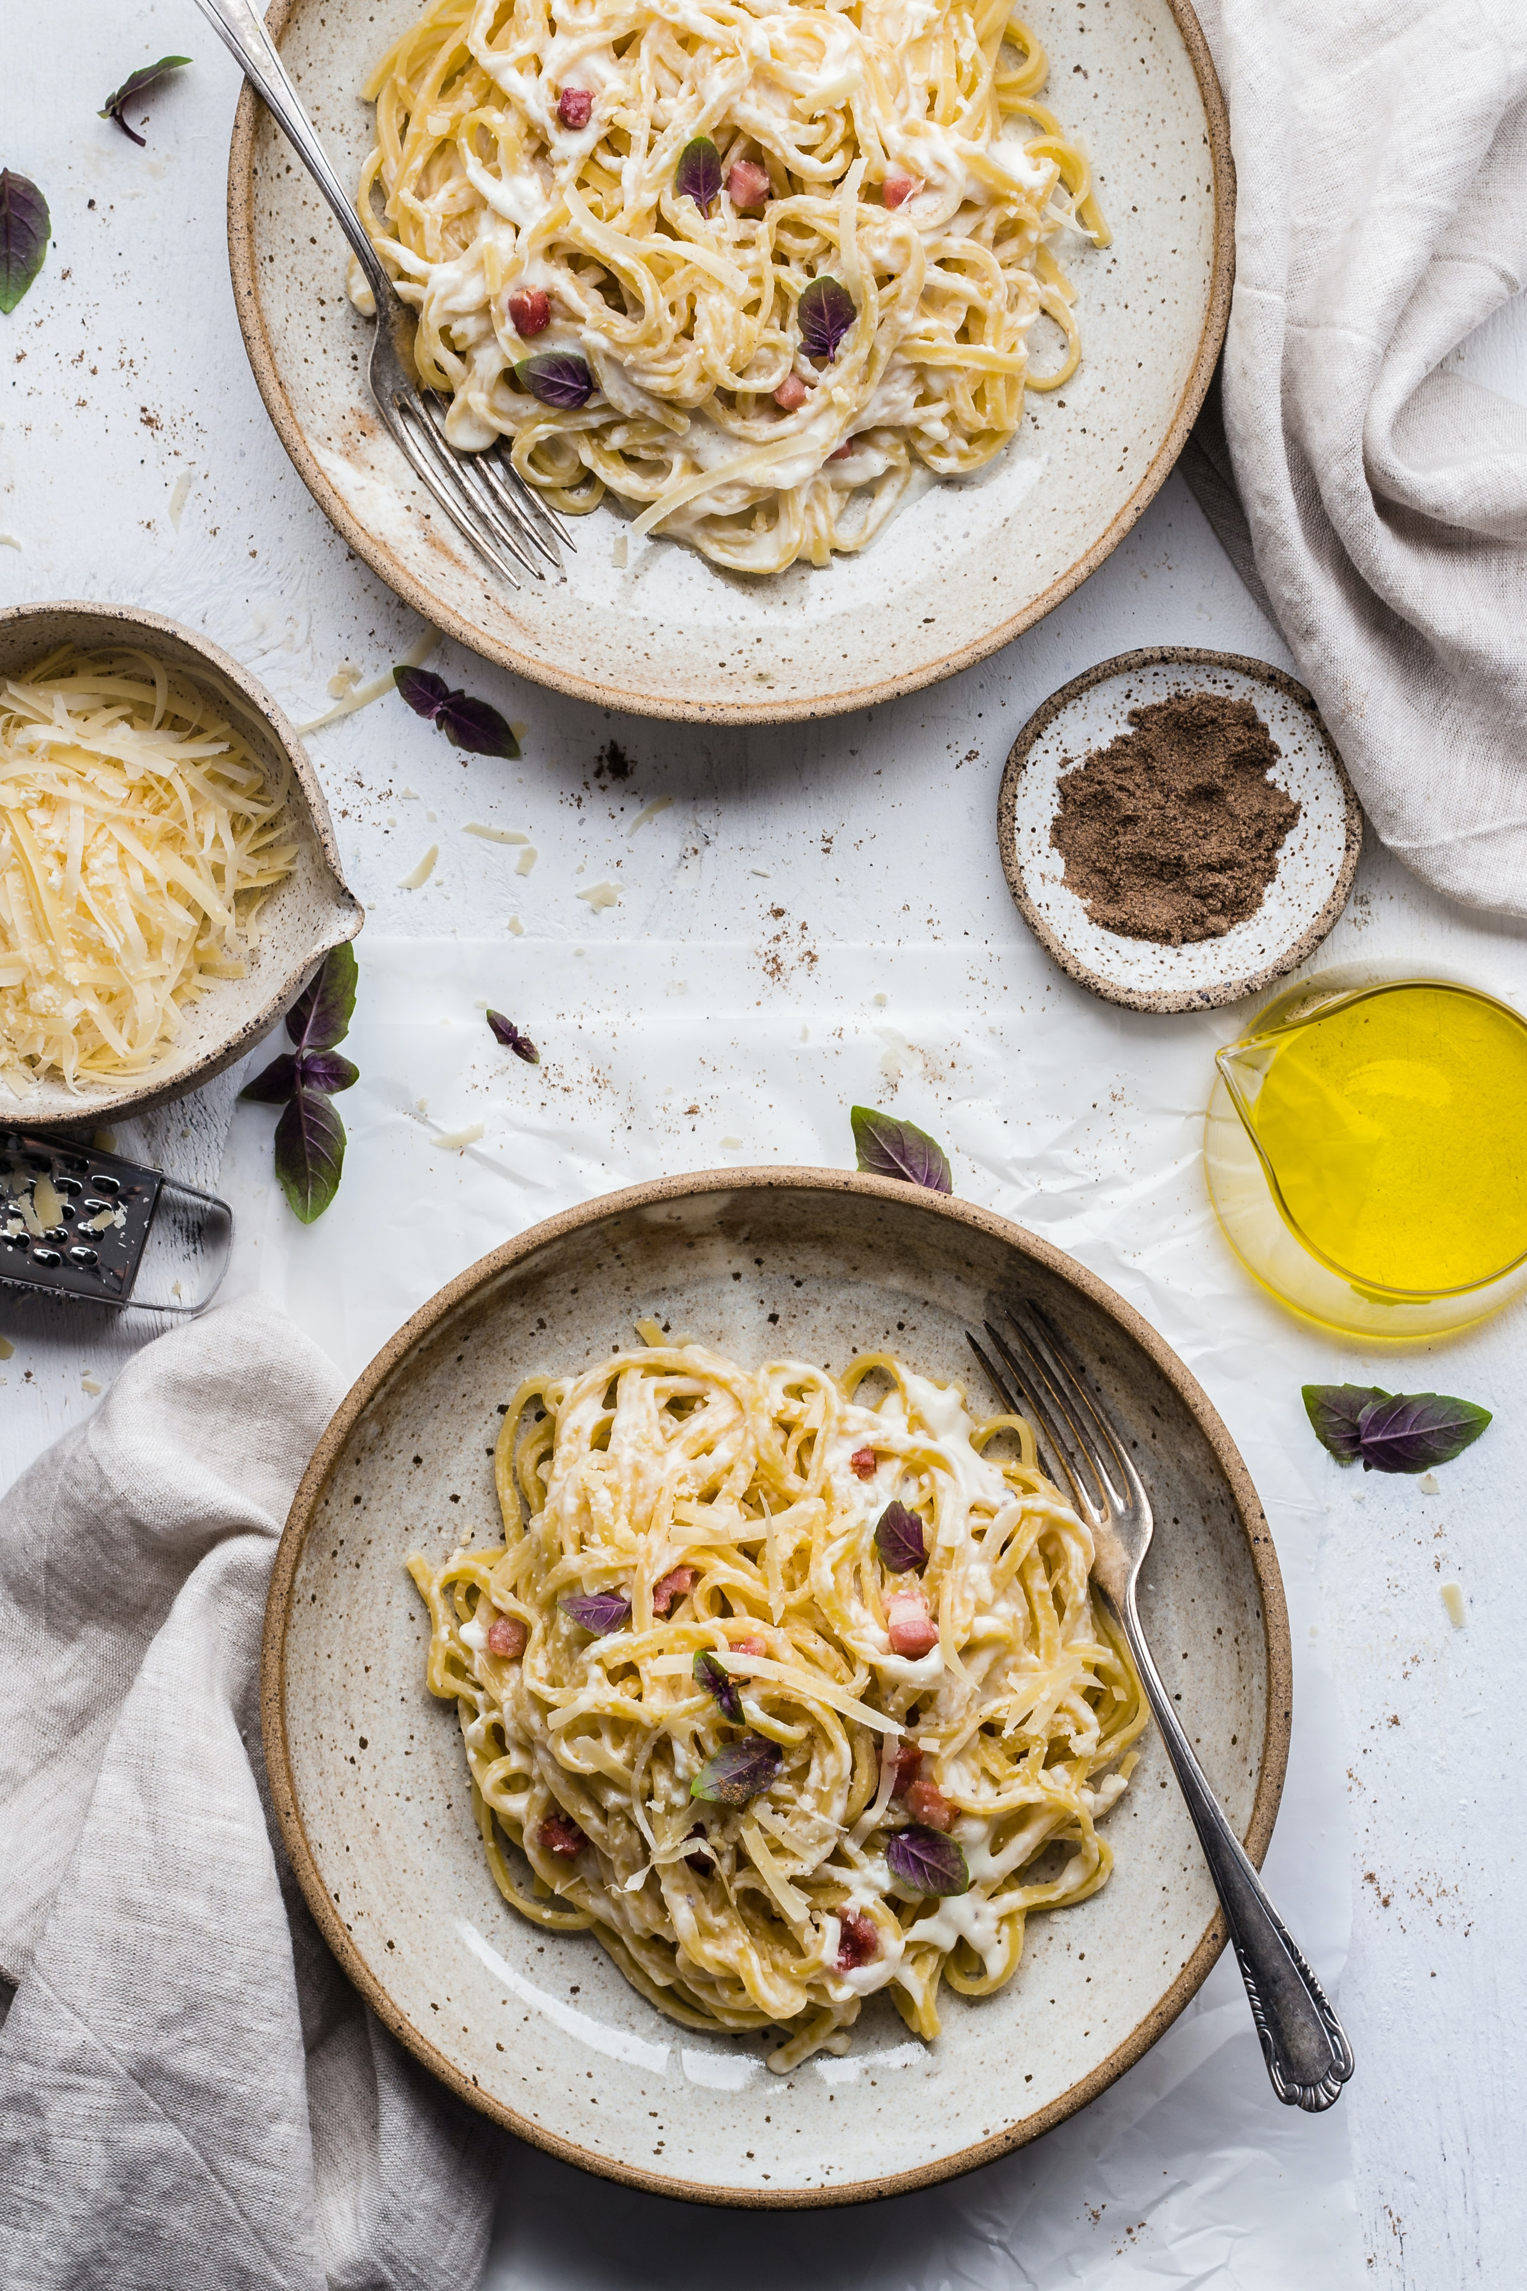

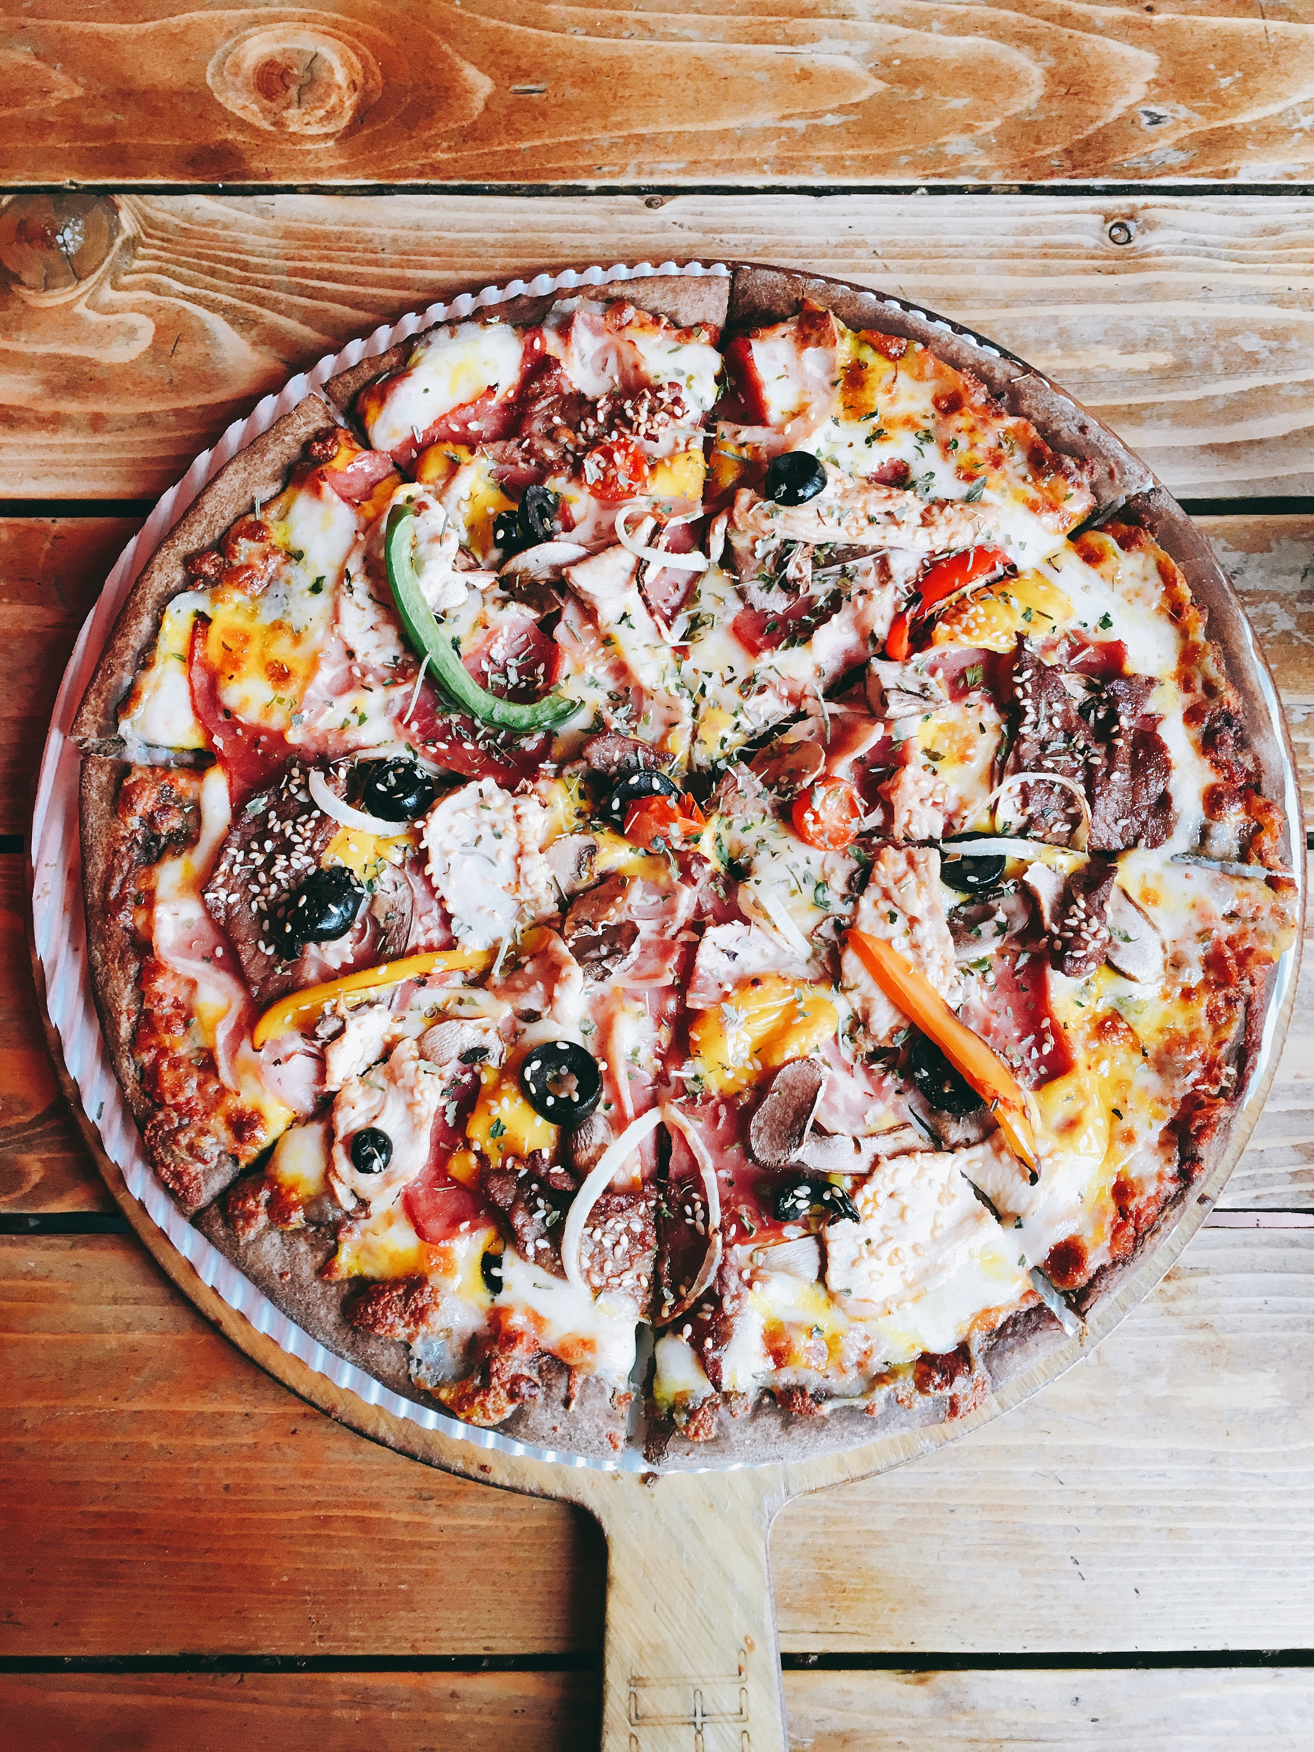

OUR STORY

La Casa is a rustic fine dining restaurant in the heart of Halifax. We began our humble beginnings in Halifax with a dream to create a mini-Italy in 2001. Since then, we've experimented with fusions and collaborated with our chefs to design a menu that holds dishes based on recipes over 100 years old to new and fun appetizers and drinks. Our handmade pasta and pizzas are both gluten-free and non-GMO. Our farm-to-fresh ingredients, finely aged wines, and expert chefs guarantee you an authentic Italian experience.

It means 'The House' offering familiar Italian cuisine with a key to your

*cuore*(heart)! Enjoy a dining experience like no other with a view from brunch to dinner.

OUR REVIEWS

The Coast Magazine says:

"A magical experience at La Casa, a must-visit for anyone in Halifax, mouthwatering Antipasti and flavorful, gluten-free Focaccia, right in South Street, with a stunning view of downtown. Beautiful outdoor seating, great for a date or a group dinner. Finally, a glass of their best wine and a stroll through the gardens to end the night.

Megan Priestly:

I celebrated my 30th birthday here a few days ago, my favorite place in all of Halifax ever since I've moved here. The waiters were so friendly, the whole atmosphere was vibrant, and the head chef Gina brought out a specially made heavenly birthday Fettuccine Jumbo Shrimp pasta, complete with Fettucine 'icing'. A birthday like no other, La Casa holds a special place in my heart, and I highly recommend this place to anyone.

Date of visit: January 2021

**Meet The Team**

Chef Gina Canva came from humble beginnings, being raised by a mother to 4, she spent most of her time in her grandparent’s kitchen, where she was constantly cooking up new savory dishes so she could help feed her family of 5. She started to help her grandparents with chores around the kitchen, and soon developed a love for the multitude of different techniques used to roll out soft pastry dough and many others. She was inspired by how food can tell a story and convey cultural ideas, as well as how it can bring people together. Her current position as head Chef at the La Casa restaurant reflects her dedication to nourishing food as well as his heritage.

Gina graduated from the culinary institute of Florence in Italy. She then started working as a sous chef at Enoteca Pinchiorri, where she helped to assemble dishes and work as part of a team to keep up with the orders coming into the kitchen. She especially excelled in the art of cooking Risotto Alla Milanese to the exact right doneness, perfecting the art of adjusting the temperature of the plate to ensure the dish either continued to cook or cooled down accordingly depending on the availability of the servers. Working as part of a large culinary team helped to hone her communication as well as leadership skills.

The skills she gained at Enoteca Pinchiorri allowed her to make the jump to head chef at La Casa, which she has worked at for the past 10 years. She creates her own recipes and has a strong influence on the menu which brings together Italian food from all cultures. In her spare time, Canva enjoys an active life and engages in fitness camps, which drives her demand for nutritious food. Every meal that she creates reflects these values, providing not only excellent taste, but also nourishment for the mind and body.

**MAIN MENU**

**A N T I P A S T I**

**Stuzzichini:**

risotto croquette, Salami rolled with fresh

Mozzarella, flash-fried artichoke, mushroom bruschetta,

tomato bruschetta, Prosciutto-wrapped grissini 16

**Calamari:**

flash-fried, sauced with roasted garlic, chilies,

tomato, ‘Arrabbiata’ 11

**Risotto Croquettes:** San Marzano tomato, Prosciutto

di San Daniele, fresh Mozzarella center, tomato, basil

pesto sauce 11

**Local Mussels:**

sautéed with onion, browned garlic, tomato,

basil, white wine 11

**Pan Seared Scallops:**

grapefruit & tarragon brown butter

sauce, toasted almonds 13

**Jumbo Shrimp:**

sautéed with roasted garlic, cream,

white wine, Italian parsley 11

**Bruschetta:**

brushed with garlic, topped with fresh herbs,

chopped tomato, Montasio, Parmigiano 8

**Italian Seafood Zuppa** 12

**Marinated Grilled Vegetable Salad:**

organic greens, warm

Goat cheese, basil pesto, balsamic vinaigrette 11

**Caesar Salad:**

crisp smoked Bacon, grilled focaccia

croutons, classic Caesar dressing, Parmigiano dusting 11

**Spinach Salad:** fresh strawberries, marinated red onions,

honey pecan dressing, flash fried Goat Cheese 11

Add Roasted Chicken 3

**Red & Green Shredded Cabbage Salad:** warm Bacon

dressing, roasted garlic, tomato, E.V. olive oil, balsamic,

Parmigiano 11

**P A S T E A S C I U T T E**

**8-Layer Lasagna:** homemade pasta layered with slowsimmered Ragù,

béchamel, Mozzarella, Parmigiano 19

**Linguine Frutti di Mare:** Mussels, Scallops, Clams, Jumbo

Shrimp, tomato, garlic, fresh herbs, chilies, white wine 22

Gnocchi, roasted cherry tomatoes, zucchini, peas, basil, Grana

Padano 19

**Agnolotti all’Aragosta:**

NS Lobster, lemon & Mascarpone

filling, roasted garlic, San Marzano tomato, splash of cream,

Parmigiano Fonduta, dusted crispy crumbs 26

**Spaghettini alla Carbonara:**

smoky Bacon, egg, cracked

black pepper, Parmigiano 18

**Penne Salsiccia:**

handmade Sausage, charred rapini, chili

flakes, Parmigiano 19

**Spaghettini Bolognese:**

slow-simmered Ragù, Parmigiano 19

Handmade Ravioli, wild mushroom, roasted free range

**Chicken & Cambozola stuffing:**

Sherry cream sauce 19

**Fettuccine Jumbo Shrimp:**

garlic, slow-roasted cherry

tomatoes, spinach, fresh basil, white wine & cream 20

**Penne Roasted Chicken:**

Prosciutto, caramelized onions,

wild mushrooms, cream, Parmigiano 20

**Linguine Aglio e Olio:**

E.V. olive oil, roasted garlic, chilies,

Parmigiano, herb-infused breadcrumbs - Anchovies are

optional 18

**P I Z Z E & F O C A C C I A**

**Thin Crust Pizza:**

Margherita, tomato, basil pesto

Genovese & fresh Mozzarella 16

**Thin Crust Pizza Wild Mushrooms:**

tomato, smoked

Bacon, arugula, Asiago, balsamic drizzle 17

**Thin Crust Pizza, 4-Carne:**

tomato, housemade Sausage,

Salami, Pancetta, Prosciutto crudo, Mozzarella 17

**Thin Crust Pizza Chicken:**

tomato jam, caramelized

onions, Fontina cheese, spinach 17

**Thin Crust Pizza, Housemade Sausage:**

tomato,

peperonata, Montasio cheese, chilli oil 17

**Thin Crust Pizza Vegetariana**:

tomato, marinated grilled

vegetables, crumbled Goat Cheese, pine nuts, balsamic

drizzle 16

**Homemade Ligurian Focaccia:**

free range Chicken, crispy

Pancetta, avocado, arugula, chili aioli, mixed greens 15

**Mercato Burger:**

chopped Beef Tenderloin, seared

Provolone, sweet onions, Bacon, tomato jam, garlic aioli,

romaine, toasted focaccia bun, hand-cut fries 17

**P R I N C I P A L E**

**Italian Seafood Stew:**

Jumbo Shrimp, Scallops, Mussels,

Clams, Haddock, sautéed with tomato, peperonata, white

wine, basil pesto, garlic toast 28

**Chicken Parmigiana:**

topped with Mozzarella, baked with

San Marzano tomato sauce, Fettuccine all’Alfredo 26

**Pan Seared Halibut:**

orange hazelnut gremolata, citrus

beurre blanc, grilled asparagus. honey glazed carrots,

browned baby potatoes 29

**Grilled Beef Tenderloin:**

Cognac green peppercorn sauce,

White Truffle whipped potatoes, summer vegetables 31

**Atlantic Salmon:**

seared, wildflower honey & balsamic

glaze, lemon & fresh herb butter sauce 26

**Grilled Rack of Lamb:**

pistachio crusted, blackcurrant

demi-glace sauce, rosemary potatoes, fire roasted peppers 29

**Pork Tenderloin:**

wrapped with Pancetta, roasted, browned

garlic, Sherry cream sauce 26

**C O N T O R N I**

**French Fries**: hand-cut, sea salt, Parmigiano, herbs 6

**Penne:** tomato, basil pesto Genovese, Parmigiano 7

**Fettuccine all’Alfredo:** cream, Parmigiano 7

**Additional vegetables & potatoes** 5

**DOPO CENA/ DESSERT MENU**

**C A F F È & T È**

**Illy Espresso / Illy Macchiato** 3.50

**Illy Cappuccino / Illy Caffè Latté** 4

**Custom Blend Coffee / Teas** 3.25

**Homemade Hot Chocolate** 4.50

**Caffè Corretto a shot of Illy Espresso spiked**

**with your favourite Liqueur**  **5**

**Bailey’s Coffee 1.5oz, Bailey’s Irish Cream,**

**Tia Maria, fresh whipped cream**

**Any Specialty Coffee 1.5oz, your choice of**

**Liqueur, fresh whipped cream** 9

**D I G E S T I V I 1oz**

**Courvoisier VS** 8

**Remy Martin VSOP** **9**

**Grappa di Picolit, Bepi Tosolini** 12

**P O R T O 2oz**

**Dow’s 7-Year Old LBV** 8

**Taylor Fladgate 10-Year Old Tawny** 9

**Taylor Fladgate LBV** 8

**D O L C I & G E L A T I**

**Tiramisù:** **10**

ladyfingers soaked with Espresso &

Brandy, mascarpone mousse, dark chocolate

cocoa dusting

**Strawberry Rhubarb Cheesecake:** **10**

grahamcracker crust, fresh whipped cream

**Zuccotto:** **10**

chocolate & stracciatella layers,

Tia Maria-spiked dark chocolate ganache

**Butterscotch Pie:** **10**

shortcrust, creamy butterscotch, salted toffee crumble,

amber rumspiked whipped cream

**Classic Vanilla Crème Brûlée:** **10**

brown sugar

torched

**White Chocolate Roulade:** **10**

vanilla & pistachio

sponge cake rolled with raspberry jam, white

chocolate Mascarpone mousse, fresh raspberries,

white chocolate curls

**Coffee Toffee Sundae:`** **10**

illy espresso & vanilla

gelati, layered with hot fudge sauce, toffee crumble,

fresh whipped cream, hazelnut biscotti

**Affogato al Caffè: 10**

vanilla gelato doused with Illy

Espresso, splash of Baileys, fresh whipped cream,

chocolate shavings

**Handmade Italian Gelati & Sorbetti**,

Ever-changing flavours **3 per scoop**

CITATION:

1. il MERCATO

AUTHOR: il MERCATO

URL: <https://www.il-mercato.ca/>

Hour and Location

La Casa

6385 South St

Halifax, NS

B3H 4J4

**Phone: (902)-123-4567**

**Email:** [**lacasa@gmail.com**](mailto:lacasa@gmail.com)

**Hours of Operation**

Mon:  11:30 am–11:00 pm  
Tue:  11:30 am–11:00 pm  
Wed:  11:30 am–11:00 pm  
Thu:  11:30 am–12:00 am  
Fri:  11:30 am–12:00 am  
Sat:  11:30 am–5:00 pm  
Sun:  11:30 am–5:00 pm

**Follow us on Facebook, Instagram**

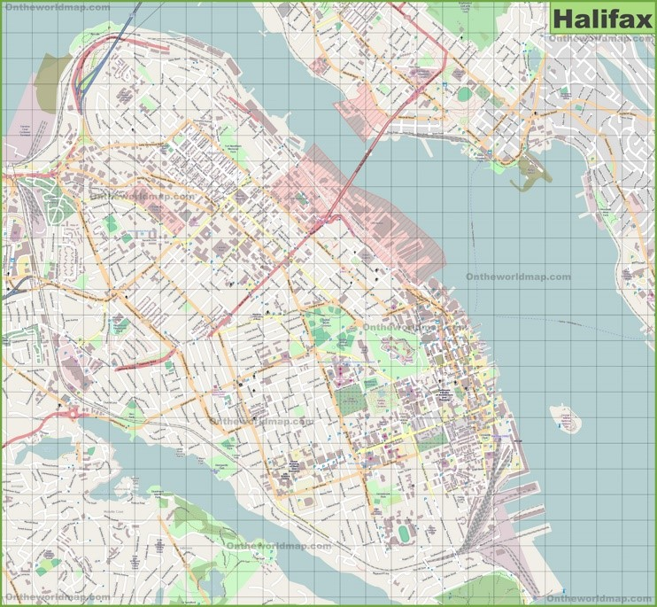

**Citation**

**Author:** ontheworldmap.com

**URL:** [**https://ontheworldmap.com/canada/city/halifax/large-detailed-map-of-halifax.html**](https://ontheworldmap.com/canada/city/halifax/large-detailed-map-%C2%A0%20%C2%A0%20%C2%A0%20%C2%A0%20%C2%A0%20%C2%A0of-halifax.html)

**Date: 20th Oct 2021**

Contact us

Header

* navigation bar - Hour & location, Menu, Meet the team, Our story, reviews
* Restaurant logo(logo.jpg)

Main

1. Phone no. - 902 123 4567
2. Email - [lacasa@gmail.com](mailto:lacasa@gmail.com)
3. Ask user to input information(webform)

* Have a question or comment? Feel free to send us a message! We will get back to you as soon as possible!
* name
* email
* phone number
* Your message

1. Insert img5.jpg

<!-- Citation for external content(img5):

Author: Photo by [Louis Hansel](https://unsplash.com/@louishansel?utm_source=unsplash&utm_medium=referral&utm_content=creditCopyText) on [Unsplash](https://unsplash.com/s/photos/italian-restaurant?utm_source=unsplash&utm_medium=referral&utm_content=creditCopyText)

URL: <https://unsplash.com/photos/W75bFvPPrK8>

Date accessed: 11 - Oct - 2021

-->

Footer-contact us(link), address- 6385 South St, Halifax, NS B3H 4J4

